**NAAN MUDHALVAN**

**PROJECT REPORT ON**

**Owl-M: A Material Design Study App**

**TEAM ID: 99ABE7159143787AE394BD1E186EEA17**

**SUBMITTED BY**

**TEAM LEADER: S.MANOJ**

**TEAM MEMBERS:**

**H.MANOJ MANIKANDAN.S M.MADAVAN**

# INTRODUCTION

* Owl-M is an innovative Material Design study app developed in Android Studio that offers a seamless and visually appealing way for students to study and manage their academic tasks. The app is designed with a clean and intuitive interface that provides an easy-to-use platform for users to organize their study materials and track their progress.
* With Owl-M, students can create customizable study plans, set reminders for important deadlines, and access a wide range of learning resources. The app also features a powerful note-taking tool that allows users to take and organize their notes efficiently.
* Owl-M follows the principles of Material Design, offering a minimalist yet functional approach that enhances user experience. It features bold typography, vibrant colors, and intuitive navigation that give users a sense of control and ease-of-use.
* Whether you are a student looking to optimize your study habits or an educator seeking to provide your students with a robust study tool, Owl-M is the perfect solution for you. With its advanced features and user-friendly interface, Owl-M is poised to revolutionize the way students study and learn.

# ABOUT THE PROJECT

* The Material Design Study app is an Android app project that is built using Android Studio, which allows users to explore and study different elements of Google's Material Design guidelines. Material Design is a design language developed by Google that emphasizes the use of grid-based layouts, bold colors, and consistent typography to create clean and visually appealing user interfaces.
* The Material Design Study app project typically includes a variety of screens and features that showcase different aspects of Material Design, such as animations, transitions, widgets, and typography. It may also include examples of best practices for designing mobile apps, such as responsive layouts, scalable graphics, and touch-friendly controls.
* To build the Material Design Study app, you can use Android Studio, which is an integrated development environment (IDE) that provides tools for designing, coding, testing, and debugging Android apps. Android Studio comes with a variety of templates and components that you can use to create your app, as well as APIs and libraries that allow you to access system features and third-party services.
* When building the Material Design Study app, it's important to follow the Material Design guidelines closely, as this will ensure that your app is consistent with other Material Design apps and provides a familiar and intuitive user experience. You can also use tools such as the Android Design Support Library and the Material Components Library to make it easier to implement Material Design elements in your app.
* Overall, building a Material Design Study app in Android Studio can be a great way to learn about Material Design and to develop your Android app development skills.

# PROBLEM DEFINITION AND DESIGN THINKING

Problem Definition :

* To design and develop a user-friendly Android application that helps users study material design concepts effectively. The app should provide easy access to material design guidelines, components, and best practices, as well as offer interactive exercises and quizzes to help users reinforce their understanding. The app should also be visually appealing and follow the material design principles and guidelines, providing a seamless user experience. The target audience for the app could be beginner or intermediate-level designers, developers, or anyone interested in learning about material design principles and best practices. The app should be scalable, easily maintainable, and compatible with different screen sizes and versions of Android.

**Design Thinking :**

* Design thinking for the material design study app involves a user-centered approach that focuses on the needs of the users and their interactions with the app. Here are the steps that could be followed:
* **Empathize:** Understand the users and their needs - Who are the users of the app? What are their goals and challenges? What motivates them to study material design? What are their preferred learning styles?
* **Define:** Define the problem statement and user requirements - Based on the insights gathered from the empathy phase, define the problem statement, and identify the key features and functionalities that the app should have to meet the users' needs.
* **Ideate:** Brainstorm and generate ideas - Use various ideation techniques, such as brainstorming and mind mapping, to come up with multiple ideas and concepts for the app.
* **Prototype:** Create low-fidelity and high-fidelity prototypes - Develop prototypes of the app to test its usability and functionality. Create low-fidelity sketches or wireframes to get feedback on the basic layout and navigation of the app. Then, develop high-fidelity prototypes that mimic the final product's look and feel.
* **Test:** Get user feedback and iterate - Test the app with real users to get feedback on its usability, design, and functionality. Use the feedback to make necessary improvements and iterate until the app meets the users' needs and expectations.
* **Implement:** Develop and launch the final product - Based on the feedback and iterations, develop the final version of the app and launch it on the Google Play Store. Keep testing and refining the app based on user feedback to ensure its success and relevance over time.
* By following these steps, you can create a user-centered material design study app that meets the needs of your target audience and provides a seamless and engaging learning experience.

**Hardware Requirements :**

Processor: Dual-core Intel corei5

RAM: 8GB

Storage: 200GB

Operating System : MacOs/Linux/Windows

# SYSTEM CONFIGURATION

**Software Requirements :**

Java Development Kit (JDK) : Install JDK version 8 or higher on your system.

Android Studio : Download and install the latest version of Android Studio. Android SDK : Android Studio includes the Android SDK, which you will need to build and run your app. Material Design Library : Add the Material Design library to your project by including The following dependencies in your build.gradle file: dependencies {

implementation 'com.google.android.material:material:1.5.0-alpha02' }

# ADVANTAGE AND DISADVANTAGE

**Advantages :**

**1.Consistency :** Material Design provides a set of guidelines for design and interaction that can make the app more consistent and easier to use.

**2.User engagement :** The design language provides a visually appealing and interactive UI, which can attract and engage users.

**3.Familiarity :** Material Design is widely used in Android apps, so users are likely to be familiar with it, making it easier for them to navigate and use the app.

**4.Flexibility :** Material Design is flexible and allows for customization, so developers can create a unique look and feel for their app while still following the design language.

**5.Integration :** Material Design is integrated into the Android platform, making it easy for developers to implement it in their apps and ensure compatibility with various Android devices.

**6.Better development :** Material Design provides a clear and concise set of guidelines, which can make the development process more efficient and effective.

**Disadvantages :**

**1.Steep Learning Curve :** Material design is a complex design language, and it requires developers to learn new design patterns, styles, and elements. It can take a significant amount of time for developers to master these concepts, which may delay the development process.

**2.Limited Customization :** While material design offers a consistent and cohesive look and feel across all apps, it also limits the amount of customization that developers can do. This can make it difficult to create unique and personalized designs for apps.

**3.Compatibility Issues :** Material design elements and components may not be compatible with older versions of Android, which can limit the reach of the app to a certain subset of users.

**4.Increased File Size :** Material design elements often require additional resources, such as icons, fonts, and graphics, which can increase the size of the app. This can make it difficult to optimize the app for low-end devices with limited storage space.

**5.User Expectations :** While material design is a popular and widely used design language, it also creates certain user expectations. Users may expect all apps to follow material design principles, which can make it difficult for developers to create unique and differentiated experiences for their apps.

**ANDROID ARCHITECTURE**

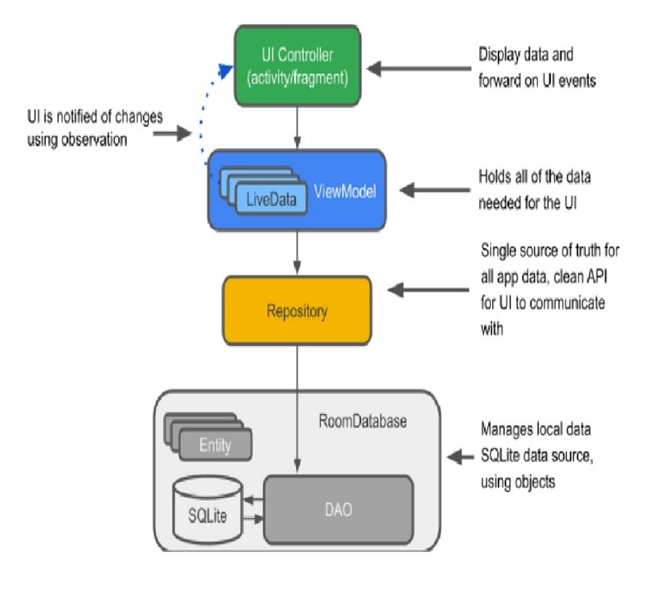

**OUTPUT OF THE APPLICATION**

**Login Page :**

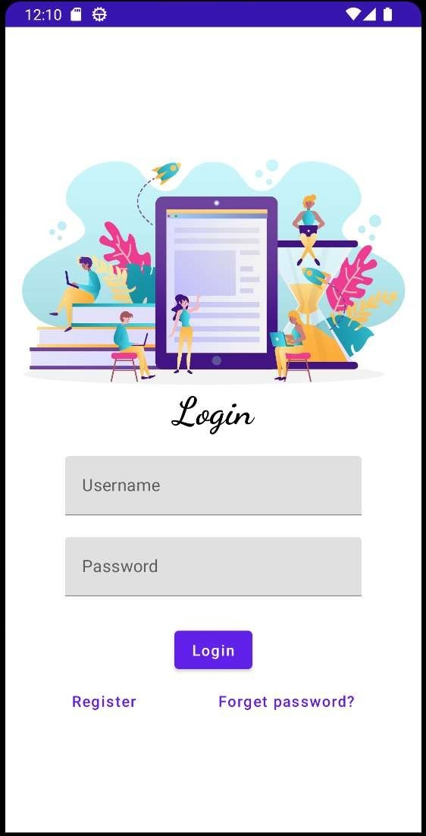

Register Page :

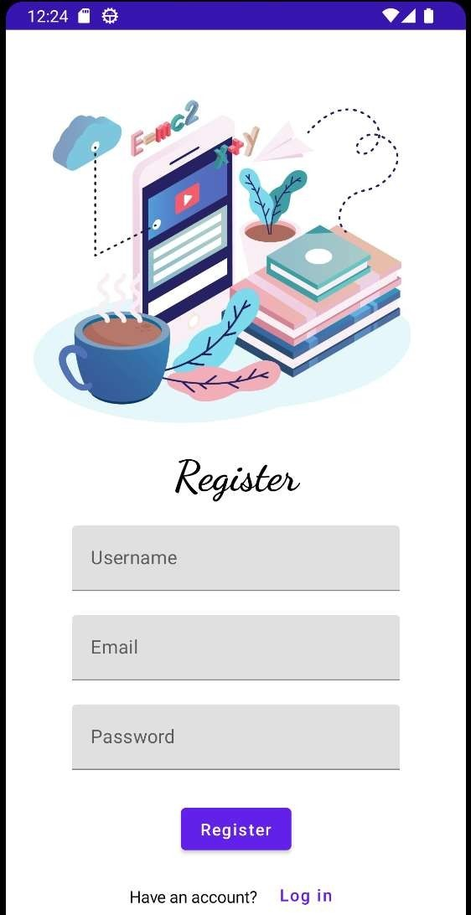

Home page :

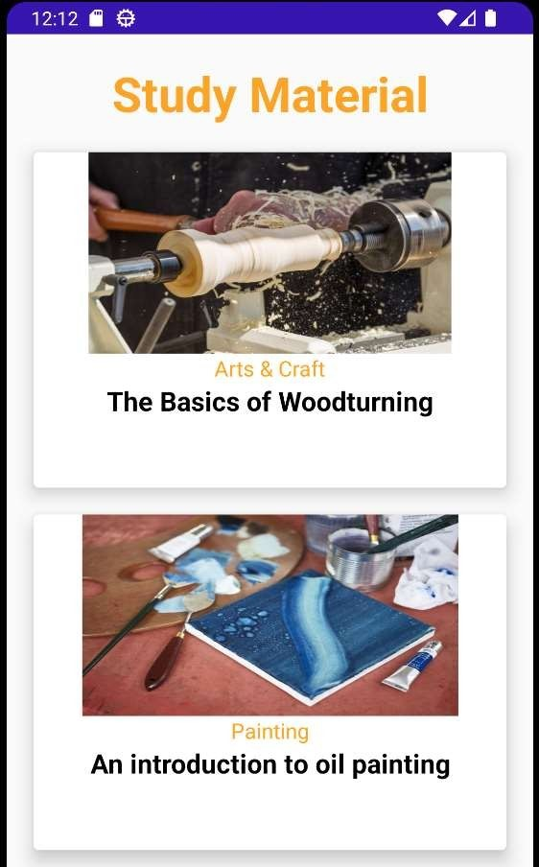

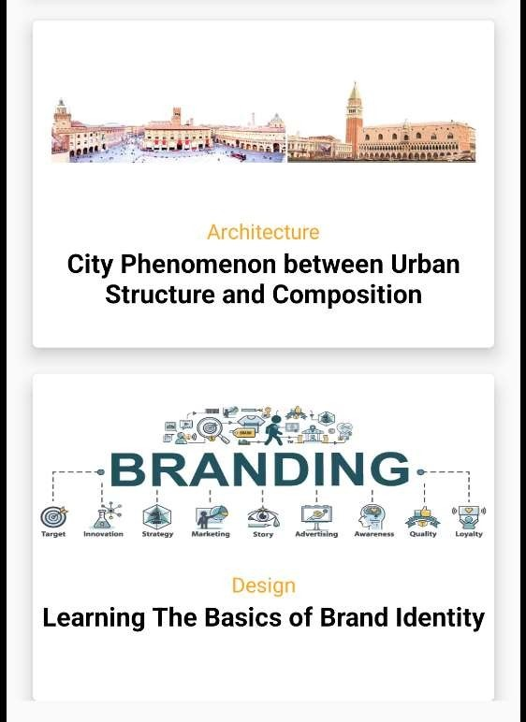

# CONCLUSION

* Designing a material study app involves creating a visually appealing and user- friendly interface that adheres to the Material Design principles. This can be achieved by implementing design components such as buttons, cards, and menus, using appropriate color schemes and typography, and ensuring that the app layout is consistent and intuitive.

* In addition to design considerations, the app should also incorporate features such as user authentication, data storage, and content delivery, such as through APIs or databases. Testing and debugging should be conducted throughout the development process to ensure that the app is functioning as intended and meets user expectations.
* Overall, designing a material study app in Android Studio requires attention to detail, creativity, and technical proficiency, but can result in a high-quality app that provides a valuable learning resource for users.